11. Emulator on your AAPS Smartphone V 2.1 for 301


Please note that with autoISF you are in an early-dev. environment, where the user interface is not optimized for safety of users who stray away from intended ways to use. Good safety features exist, but these are only as good as the development-oriented user understands and implements them. This is not a medical product, refer to disclaimer in section 0

Available related case studies:

Case study 11.1:

11.1 Installing the Emulator on your smartphone
11.2 Analyzing ,,,, on the smartphone
11.3 Options available in iAPS / Open iAPS
11.4 Storing and exporting data
11.5 Real-time checking a „what-if“ question
using speech synthesis
11.6

The Emulator on the PC discussed in section 10 is very good for making your initial tuning for a meal spectrum, when weighing different effects over the entire course of time after each meal, for a variety of your meals.

A very useful additional tool, is the Emulator running on the AAPS loop smartphone
Note that iOS based autoISF variants cannot use the Emulator. See section 11.

Installation guide and basic use instructions see here: https://github.com/ga-zelle/APS-what-if/blob/A3.2.0.4_ai3.0.1_dev/Documentation%20in%20English/A%20%20README.md

the following needs lot of work , maybe I can do it by end May 2024, but co-author would be very welcome - - - -

11.1 Installing the Emulator on your smartphone

(copy and slightly expand on ga-zelle? Or link to it, and below focus on an application for FCL analysis of ace vs pp weight ??))

11.1.1 Installing QPython3L

11.1.2 Installing …

11.1.3 ….

11.2 Analyzing ….. on your smartphone

You can produce, for any of your recent meals, a table in which the key data (bg, iob, TBR and SMB given, and contribution of the various autoISF categories) can be seen:

….how…

… example…

Additionally, key info from this table can be presented in graphical form:

… how …

… example:
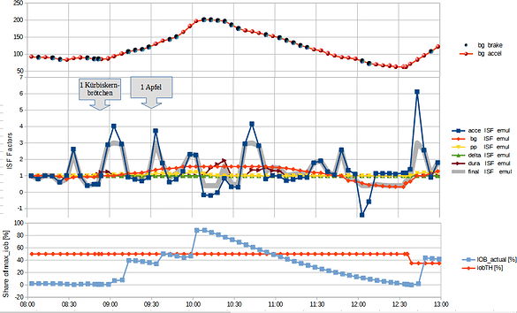

11.3 Options available in iAPS / Open iAPS (to be reviewed by Robert)

The Emulator will not work in the iOS world. However, iAPS / Open iAPS offer in their autoISF variants access to tables that show autoISF contributions to resulting SMB sizes, and are similar to what was presented in section 11.2:
(insert example)

11.4 Storing and exporting data

11.5 Real-time checking a „what-if“ question using speech synthesis

The emulator on your smartphone can help clarify a "what if..." question.

In running the Emulator on the phone, one can define in the .vdf file of the Emulator, which setting one would like to be differently aggressive than in the active AAPS.

(elaborate how to do that) ….

At times when this different setting would have resulted in smaller or greater SMB insulin delivery, the notification is reported via speech synthesis, and you can assess the situation in real-time yourself. If for instance a suggested extra or bigger SMB makes sense, you can add this portion manually* ….and in time observe, whether this bolus was OK and you should switch to the different setting you were investigating.

*In Full Closed Loop, you don't need any buttons at the bottom of the AAPS main screen. But for such test phases it is practical to reinstall the insulin button at the bottom of the AAPS main screen (Preferences/Overview/Buttons/Insulin -> ON).

After a few iterations, you'll get a feel for whether you want to incorporate this tightening into the active AAPS.

Warning: Your settings must always work for a variety of meals. Do not put too much effort into optimizing one situation!

